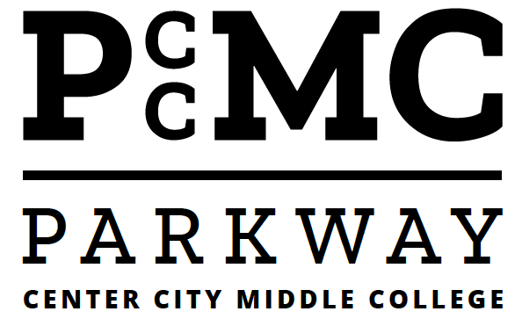
Parkway Center City Middle College

School-Parent Compact

2018-2019 School Year
Revision Date 04/12/2018
Dear Parent/Guardian,

The parents, students, and staff of Parkway Center City Middle College partnered together to develop this school-parent compact for achievement. Parents are encouraged to attend annual revision meetings held during the April HAS Meetings each year to review the compact and make suggestions based on student needs and school improvement goals. Parents are also encouraged to participate in the School Family Engagement survey that is also used as a tool to collect parent feedback regarding the current Title I programs, policies and family engagement.

To understand how working together can benefit your child, it is first important to understand the district’s and school’s goals for student academic achievement.

THE SCHOOL DISTRICT OF PHILADELPHIA ANCHOR GOALS:
- 100% of students will graduate, ready for college and career.
- 100% of 8-year-olds will read on grade level.
- 100% of schools will have great principals and teachers.
- SDP will have 100% of the funding we need for great schools, and zero deficit.

Parkway Center City Middle College GOALS:
- 72% of 9th grade students will score proficient or advanced on the Algebra I Keystone
- 87% of students will score proficient or advanced on the English I Keystone
- At least 75% of 9th grade students will be on track to earn a minimum of 5 quality credits for each marking
- At least 50% of students will attend 95% of days or more
- At least 95% of 12th grade students will be on track for graduation

To help your child meet the district and school goals, the school, you, and your child will work together:

SCHOOL/TEACHER RESPONSIBILITIES:
- Host regular workshops designed for parent and child to ensure a successful high school experience and appropriate preparedness for college and career. Probable topics include: Navigating High School; Goal Setting and Planning; College Planning; The College
- Provides support to families around using technology/the Parent Portal for progress monitoring.
- Provide parents reasonable access to staff to support parents and families.
- Open house/Back to School Night including Annual Title I Meeting
- New Student Orientation involving Parents 6/7/18– School District and Parkway Center City Middle College expectations.
- Parkway Center City Middle College’s initiative regarding parental / guardian involvement, including holding Home and School Elections and forming the School Advisory Council after establishing the Home and School Council.

PARENT RESPONSIBILITIES:
We, as parents, will:
- Monitor student attendance, punctuality, homework, academic progress, and compliance with Parkway Center City Middle College and the School District of Philadelphia’s Rules including respecting diversity and compliance with Anti-Bully, Anti- Harassment, and Anti-Ethnic Intimidation Policies.
- Support school and SDP policies.
- Volunteer time in school and / or work with Home and School or School Advisory Council.
- Participate in the Volunteer Family Monthly Homework Assignment Program and earn you student Instant As in Homework.
- Require student involvement in after school – extended day opportunities for students (Tutoring, Grade Recovery, Clubs, Cheerleading, Athletics, etc.)
- Require students to engage in after school / summer service oriented and enrichment activities in the community as well as with institutions of higher learning

STUDENT RESPONSIBILITIES:
We, as students, will share the responsibility to improve our academic achievement and achieve the State’s high standards. Specifically, we will:
- Attend school regularly and promptly.
- Be prepared for school and class.
- Complete all assignments to the best of your ability – Do your best to do your best work – take the time, be neat, review, and revise as needed
- Complete Institutional requirement of 120 Hours by the end of your 12th grade year.
- Set aside 2 – 4 hours nightly of quiet, undistracted time for homework, study, reading, writing, researching
- Use your assigned notebook to record and monitor Homework Assignments
- Participate in After School, Extended Day. Service Oriented, and / or Enrichment Programs provided and / or recommended by the school – including summer activities
- Be Cooperative – Comply with school and SDP rules, including the School Uniform and Dress Code Policies
- Be Respectful to and of everyone

COMMUNICATION ABOUT STUDENT LEARNING:
Parkway Center City Middle College is committed to frequent two-way communication with families about children’s learning. Some of the ways you can expect us to reach you are:
- New Student/ Summer Bridge Orientation Meeting with Parents –6/7/18 (10 am)
- Back to School Night and Title 1 Parents Meeting – TBD (5:00 to 7:00 pm)
- First Report Parent / Teacher Afternoon Conferences on 11/08/18 to 11/09/19 (1 to 3 pm); Night Conference on 11/08/18 (5:00 - 7:00 pm)
- Second Report Parent / Teacher Afternoon Conferences on 2/14/19 to 2/15/19 (1 to 3 pm)
- Third Report Parent / Teacher Afternoon Conferences on 4/16/19 to 4/17/19 (1 to 3 pm)
- End of School Year Individualized Student Conferences (Review of Student Needs / Recommended Roster for 2018-2019 School Year (To be announced)
- New Student Orientation on 6/2019
- Calls / Letters home (including Infinite Campus) regarding Academic Progress, Attendance, Punctuality, and Non- Compliance with School Rules
- Interim Reports Weeks = See Calendar
- Keystone Data reviewed with students and sent home
- Additional Meetings as requested by Parents, Teachers, Counselors and Principal
- Google Classroom
- Remind App
- PCCMC Website
- Email
- Infinite campus announcements to the Parent Portal
- Translations are available, as needed, through the Office of Translations

ACTIVITIES TO BUILD PARTNERSHIPS:
Parkway Center City Middle College offers ongoing events and programs to build partnerships with families.
- Orientations
- Back To School Night
- Monthly Home and School Meetings

