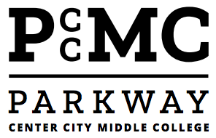
540 N. 13th St.
Philadelphia, PA 19123
Phone # (215)400-7620 Fax# (215)400-7621

Principal Anh Nguyen

October 23, 2019

Dear Member of the Class of 2020 & Parents,

The school year is quickly flying by and it is a good time for the school administration and staff to communicate the academic and behavioral standards for our seniors. The behavioral and academic standards are defined below in the form of a contract. Seniors and parents will be asked to sign the contract below and return it to school by Friday, November 1st. The contract defines the parameters that students must meet or abide by to participate in our senior culminating activities and any trips or events associated with it.

To be eligible to attend these events, seniors must meet the following requirements:

ACACDEMIC-BEGINNING WITH 1ST QUARTER GRADES

- Have grades ABOVE 70%.
- Pass their senior project

ATTENDANCE-BEGINNING 10/24/19

- LESS than 5 unexcused Absences or 8 overall absences (unless documentation is provided by a medical doctor)
- LESS than 5 unexcused latenesses

BEHAVIOR-BEGINNING 10/24/19

- LESS than 2 Behavioral Referrals

CONSEQUENCES

If a student violates the Academic, Attendance or Behavioral Expectations set forth above, seniors will lose the following privileges:
- PROM
- SENIOR TRIP
- SENIOR LUNCHEON and SENIOR REFLECTIONS NIGHT
- WALKING/PARTICIPATING IN GRADUATION EXERCISES

Please return the signed contract below and return by Friday, November 1st. Please do not hesitate to contact the school with any questions.

Sincerely,

Parkway Center City Staff and Administration

___________________________ _______ ____________________
Print Student Name Parent Name

___________________________ _______ ____________________
Student Signature Parent Signature

