SPRING SPORTS 2022
FLC/PCCMC PCCMC
BASEBALL/SOFTBALL/ BADMINTON TRACK BOYS VOLLEYBALL
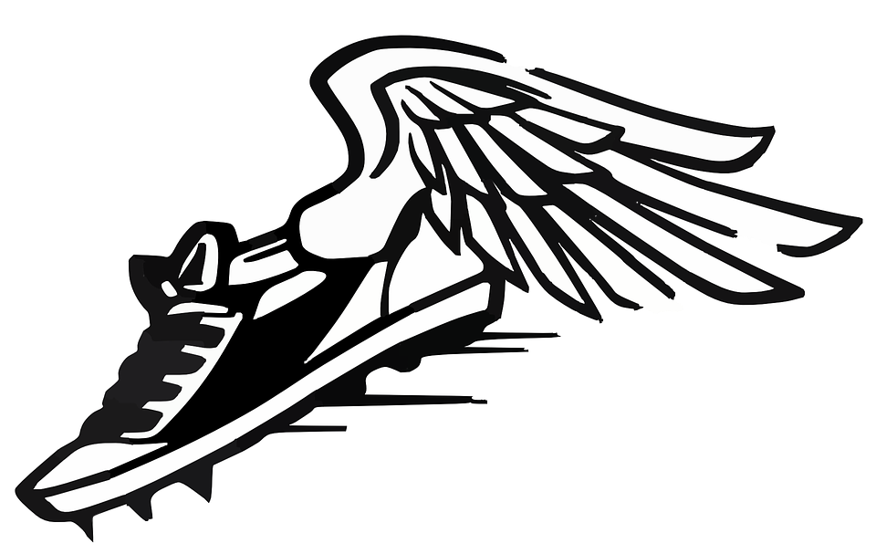
Coach Muhammad Coach Sally

IMPORTANT ANNOUNCEMENTS!
ALL SPRING ATHLETES MUST BE
FULLY VACCINATED BY MARCH 1
In order for all Spring Season student-athletes to be fully vaccinated, student-athletes will need to receive their 1st dose of the COVID-19 vaccine no later than January 25th, 2022, and their 2nd dose of the COVID-19 vaccine no later than February 15th, 2022 to ensure they will be fully vaccinated by the spring season deadline of March 1st.
*No spring sports student-athlete may participate in interscholastic activities until they can provide proof of full vaccination.
NO EXCEPTIONS!!!!!

MUST HAVE PIAA ATHLETIC PHYSICAL COMPLETE BY MARCH 1
CLICK HERE - CLICK ON CIPPE FORMS
SEE COACH SALLY OR COACH MUHAMMAD FOR MORE INFO

